VILLAGE OF RHINEBECK

2024 Temporary Sidewalk Seating/Dining Permit Application
Permit effective from April 12, 2024 until November 1, 2024

Building Department will prioritize this submission but may take up to two weeks to review and approve this application.

General Information
Establishment Name:
Business Email:
Address: | Phone:
Point of Contact:
Email: | Cell Phone:
Health Department notification or sign off: Yes: No:
Current Hours of Operation:
Do you wish to serve alcoholic beverages outdoors: ☐ Yes ☐ No
Liquor License #:
Occupancy and Other Questions:
Occupancy Calculation:
Legal Occupancy Limit: ___________
The total amount of active seating indoors and outside may not exceed the seating limits on the restaurant’s SLA license. If the restaurant does not serve alcohol, the occupancy limit is restricted to the number of tables that abide by the regulations in Attachment A.
Will an Electrical Permit for Lighting be needed? ☐ Yes ☐ No
If yes, an Electrical Permit from the Building Department is required.
Outdoor Heater(s)? – Yes: No:
If yes, please indicate on site plan and the Building/Fire Inspector inspect during your inspection.

Narrative Description
Describe your plan for the storage and removal of exterior trash and litter:
Describe your plan for accommodating waiting patrons away from the 5-foot pedestrian thruway:
Site Plan
- See Attachment A for the regulations guiding this site plan and permit.
- Detail the location and size of any additional lighting that will be utilized throughout the outdoor seating area. Please note that electrical work requires electrical permits and inspection.
- Detail the location of trees, fire hydrants, utility poles, street light poles, parking meters, bus shelters, trash receptacles and any other obstructions or other permanent street fixtures, either existing or proposed, within the sidewalk seating area.
- Include any doors leading from the establishment or abutting buildings.
- Detail barricade type and placement, if applicable.
- If there are questions, please contact the Village of Rhinebeck Building, Planning & Zoning Department at 845-876-1922 or via email at: jnoyes@villageofrhinebeckny.gov
Staff will expedite permit review and approval. Applicant will make themselves available for review comments and site visits. Permit Application approval may take longer if applicant or point of contact cannot be reached or fails to respond to correspondence.

Signature and Hold Harmless Agreement
Applicant agrees to defend the Village from and against any and all claims, suits, or actions for death or injury to persons or damage to property brought against the Village arising from any alleged claims, acts or omissions in connection with this Permit, whether or not suit is filed, unless such claim, suit or cause of action was based solely on the negligence of the Village, its employees, agents or contractors. Additionally, applicant shall indemnify the Village for any sums the Village becomes obligated to pay as damages arising out of such circumstances, except to the extent such damages are due solely to the negligence of the Village, its employees, agents or contractors. The applicant is an authorized representative/agent for the establishment.
Applicant acknowledges that the operation of the sidewalk seating area will comply with all New York State Building Code and Village of Rhinebeck Code.
Applicant certifies that all information is accurate and correct.
Applicant agrees to allow Village staff to inspect sidewalk seating at any time and comply with updates as required.
Owner/Manager Name: | Phone:
Signature of Owner/Manager:
Date:

Attachment A
Application and Operating Rules for 2024 Sidewalk Dining:
- Sidewalk dining must terminate by November 1, 2024.
- Sidewalk clearances must be sufficient to ensure a pedestrian path free of obstructions. There must be a minimum clear path of at least 4 feet width at the tree boxes or other pinch points, and a minimum clear path of at least 5 feet width otherwise.
- The entirety of the dining area must be contained within three feet of the façade of the building.
- Obstructions to entryways, emergency exits, fire hydrants, and any other public utility are prohibited. Entrances to the sidewalk dining area must maintain a three-foot wide accessway from the public sidewalk to building entryway.
- No permanent structures may be affixed to the sidewalk used for the dining area, and the area may only be occupied by chairs, tables, benches, umbrellas, heaters, and planters for the convenience of the patrons.
- If alcohol is intended to be served in the outdoor dining area, the area must be in compliance with all New York State Liquor Authority (NYSLA) laws, subject to NYSLA enforcement, and movable barriers shall be so arranged as to separate the dining area from the sidewalk and shall be installed only on the façade side of the sidewalk. Please see below requirements:
  - Barrier heights must be 36 inches high.
  - The barriers must be constructed with durable, high-quality finished materials, such as steel, wrought iron, glass, or finished woods and must be of a dark color consisting of navy blue, black, or dark green. Fabric inserts, chain link fencing, chicken wire or cyclone fencing are not permitted as barriers.
  - No advertising may be shown on the dining area barriers.
  - The sidewalk dining area and associated movable barriers may extend along the adjacent building façades up to a maximum of 25% of the total length of each neighboring façade. The Applicant must provide written permission with this Application from both the building owner and business owner for each adjacent building whose sidewalk is so utilized. Where barriers are extended beyond the Applicant's façade, the barrier may not cross alleyways, driveways, or other egressways of the public sidewalk.
- If no alcohol is being served in the sidewalk dining area, no barriers are required. All other rules of this permit will apply.
- If no alcohol is being served in the sidewalk dining area and a no parking zone is located on the adjacent public street, the dining area may be established on the curb and side of the sidewalk and will not require barriers. All other rules of this permit will apply.
- Music of any sort is expressly prohibited.
- No exterior lighting which unreasonably illuminates beyond the boundaries of the sidewalk dining area shall be permitted.
- Any propane heaters used for the comfort of diners must be located within the movable barrier area. Propane heaters must be used and installed in accordance with the manufacturer’s specifications. Propane heaters and tanks may not be stored overnight in the public way.
- Any umbrellas must be located within the movable barrier area. When open, they must not extend into the public way. Umbrellas must be of a solid, dark color consisting of navy blue, black, or dark green, and no advertising is permitted on the umbrellas.
- Tables and chairs shall be constructed of durable materials such as metal. No folding tables are permitted.
- A 36-inch clearance (access aisle) is required to accessible tables. No seating or any other obstruction shall overlap the access aisle.
- No outdoor cooking of any type is permitted on the public sidewalk or outdoor dining area.
- Operations shall comply with the Village noise ordinance. (See Chapter 120-13 of the village code.)
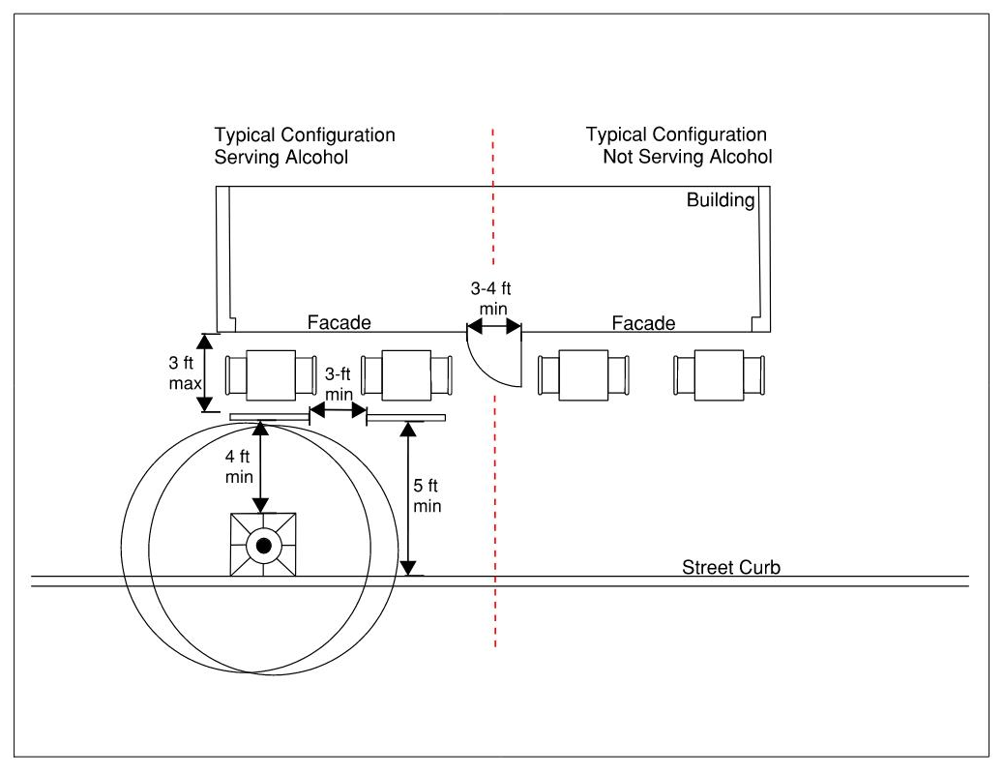
Figure 1 Typical Outdoor Dining Configuration
- These rules shall be strictly enforced, including by summary abatement of violations and revocation of permission to provide sidewalk dining.
Application Requirements:
- Provide a copy of the business’s General Liability Insurance.
- Provide a sketch drawing of the proposed dining area. Show the existing building, the area to be occupied by the dining area, the area of public sidewalk remaining for pedestrian passage, and the location of all tables and chairs. Use the reverse side if needed.
- Pay the Village the Sidewalk Dining Fee: $150 per table with a maximum of $500 per Application.
- If the establishment will be serving alcohol in the sidewalk dining area, the Applicant must provide the Village a copy of the ABC license and County license modified to allow alcohol to be served outside prior to commencing outside alcoholic beverage service.
- Provide a copy of the letter to Dutchess County Department of Behavioral and Community Health indicating the number of seats in the establishment and the additional number of seats that will be placed outside.
- Provide the written, signed, and notarized consent of the owner of the property or properties in front of which a dining area is to be operated is required. If the owner(s) are a different party than the applicant, prior to the issuance of the permit, there shall be an agreement executed by the owner and third party to defend and save harmless to Village, its officers, and employees against any loss, liability, or damages sustained by any person or to any property as a result of the operation of the dining area, together with a certificate of insurance issued to both the owner and tenant as insured and naming the Village, its officers, and employees as additional insureds, in the minimum amount of $1,000,000 single-limit general liability coverage approved by the Village Board.

